**Exercise 1: Configuring a Basic Spring Application**

**Main.java**

package com.library.service;

import com.library.repository.BookRepository;

public class BookService {

private BookRepository bookRepository;

public void setBookRepository(BookRepository bookRepository) {

this.bookRepository = bookRepository;

}

public void displayBook() {

System.***out***.println("Inside BookService");

bookRepository.fetchBook();

}

}

**BookService.java**

package com.library.service;

import com.library.repository.BookRepository;

public class BookService {

private BookRepository bookRepository;

public void setBookRepository(BookRepository bookRepository) {

this.bookRepository = bookRepository;

}

public void displayBook() {

System.***out***.println("Inside BookService");

bookRepository.fetchBook();

}

}

**BookRepository.java**

package com.library.repository;

public class BookRepository {

public void fetchBook() {

System.***out***.println("Fetching book from repository...");

}

}

**applicationContext.xml**

<?xml version="1.0" encoding="UTF-8"?>

<beans xmlns="http://www.springframework.org/schema/beans"

xmlns:xsi="http://www.w3.org/2001/XMLSchema-instance"

xsi:schemaLocation="http://www.springframework.org/schema/beans

http://www.springframework.org/schema/beans/spring-beans.xsd">

<bean id="bookRepository" class="com.library.repository.BookRepository"/>

<bean id="bookService" class="com.library.service.BookService">

<property name="bookRepository" ref="bookRepository"/>

</bean>

</beans>

**Pom.xml**

<?xml version="1.0" encoding="UTF-8"?>

<project xmlns="http://maven.apache.org/POM/4.0.0"

xmlns:xsi="http://www.w3.org/2001/XMLSchema-instance"

xsi:schemaLocation="http://maven.apache.org/POM/4.0.0

http://maven.apache.org/xsd/maven-4.0.0.xsd">

<modelVersion>4.0.0</modelVersion>

<groupId>com.maven</groupId>

<artifactId>LibManagement</artifactId>

<version>0.0.1-SNAPSHOT</version>

<name>LibManagement</name>

<url>http://www.example.com</url>

<properties>

<project.build.sourceEncoding>UTF-8</project.build.sourceEncoding>

<maven.compiler.release>17</maven.compiler.release>

</properties>

<dependencies>

<dependency>

<groupId>org.springframework</groupId>

<artifactId>spring-context</artifactId>

<version>5.3.29</version> <!-- You can change to latest stable if needed -->

</dependency>

<dependency>

<groupId>org.junit.jupiter</groupId>

<artifactId>junit-jupiter-api</artifactId>

<version>5.11.0</version>

<scope>test</scope>

</dependency>

<dependency>

<groupId>org.junit.jupiter</groupId>

<artifactId>junit-jupiter-params</artifactId>

<version>5.11.0</version>

<scope>test</scope>

</dependency>

</dependencies>

<build>

<plugins>

<plugin>

<artifactId>maven-compiler-plugin</artifactId>

<version>3.13.0</version>

<configuration>

<release>17</release>

</configuration>

</plugin>

<plugin>

<artifactId>maven-surefire-plugin</artifactId>

<version>3.3.0</version>

</plugin>

</plugins>

</build>

</project>

**OUTPUT**

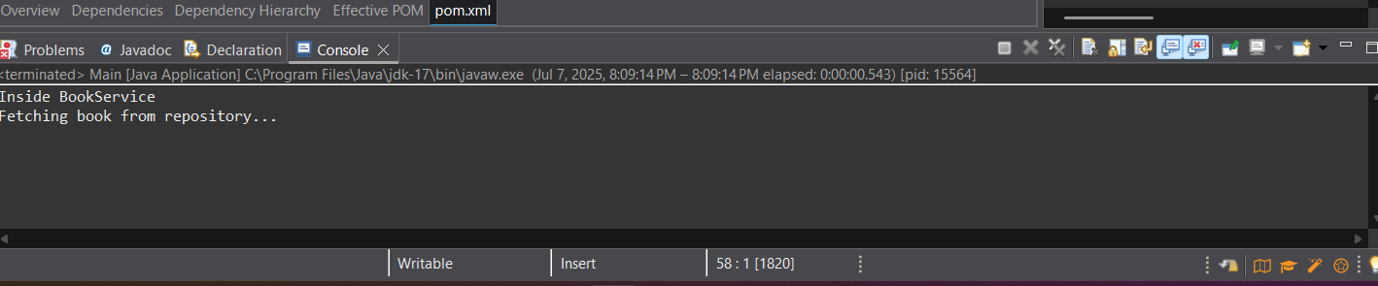

**Exercise 2: Implementing Dependency Injection**

**BookRepository.java**

package com.library.repository;

import java.util.Arrays;

import java.util.List;

public class BookRepository {

public List<String> getAllBooks() {

return Arrays.*asList*("Java Fundamentals", "Spring in Action", "Effective Java");

}

}

**BookService.java**

package com.library.service;

import com.library.repository.BookRepository;

public class BookService {

private BookRepository bookRepository;

public void setBookRepository(BookRepository bookRepository) {

this.bookRepository = bookRepository;

}

public void listBooks() {

bookRepository.getAllBooks().forEach(System.***out***::println);

}

}

**Main.java**

package main;

import org.springframework.context.ApplicationContext;

import org.springframework.context.support.ClassPathXmlApplicationContext;

import com.library.service.BookService;

public class Main {

public static void main(String[] args) {

ApplicationContext context = new ClassPathXmlApplicationContext("applicationContext.xml");

BookService bookService = (BookService) context.getBean("bookService");

bookService.listBooks();

}

}

**applicationContext.xml**

<?xml version="1.0" encoding="UTF-8"?>

<beans xmlns="http://www.springframework.org/schema/beans"

xmlns:context="http://www.springframework.org/schema/context"

xmlns:xsi="http://www.w3.org/2001/XMLSchema-instance"

xsi:schemaLocation="http://www.springframework.org/schema/beans

http://www.springframework.org/schema/beans/spring-beans.xsd

http://www.springframework.org/schema/context

http://www.springframework.org/schema/context/spring-context.xsd">

<bean id="bookRepository" class="com.library.repository.BookRepository" />

<bean id="bookService" class="com.library.service.BookService">

<property name="bookRepository" ref="bookRepository" />

</bean>

</beans>

**OUTPUT**

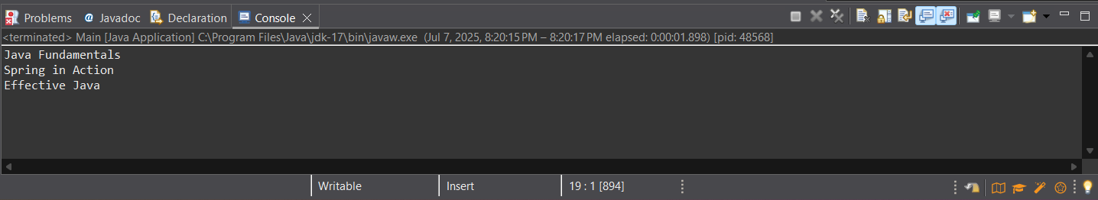

**Exercise 4: Creating and Configuring a Maven Project**

**Updated pom.xml**

<?xml version="1.0" encoding="UTF-8"?>

<project xmlns="http://maven.apache.org/POM/4.0.0"

xmlns:xsi="http://www.w3.org/2001/XMLSchema-instance"

xsi:schemaLocation="http://maven.apache.org/POM/4.0.0

http://maven.apache.org/xsd/maven-4.0.0.xsd">

<modelVersion>4.0.0</modelVersion>

<groupId>com.maven</groupId>

<artifactId>LibManagement</artifactId>

<version>0.0.1-SNAPSHOT</version>

<name>LibManagement</name>

<properties>

<project.build.sourceEncoding>UTF-8</project.build.sourceEncoding>

<maven.compiler.source>1.8</maven.compiler.source>

<maven.compiler.target>1.8</maven.compiler.target>

</properties>

<dependencies>

<!-- Spring Context -->

<dependency>

<groupId>org.springframework</groupId>

<artifactId>spring-context</artifactId>

<version>5.3.29</version>

</dependency>

<dependency>

<groupId>org.springframework</groupId>

<artifactId>spring-aop</artifactId>

<version>5.3.29</version>

</dependency>

<dependency>

<groupId>org.springframework</groupId>

<artifactId>spring-webmvc</artifactId>

<version>5.3.29</version>

</dependency>

<dependency>

<groupId>org.junit.jupiter</groupId>

<artifactId>junit-jupiter-api</artifactId>

<version>5.11.0</version>

<scope>test</scope>

</dependency>

<dependency>

<groupId>org.junit.jupiter</groupId>

<artifactId>junit-jupiter-engine</artifactId>

<version>5.11.0</version>

<scope>test</scope>

</dependency>

</dependencies>

<build>

<plugins>

<plugin>

<artifactId>maven-compiler-plugin</artifactId>

<version>3.10.1</version>

<configuration>

<source>1.8</source>

<target>1.8</target>

</configuration>

</plugin>

<plugin>

<artifactId>maven-surefire-plugin</artifactId>

<version>3.3.0</version>

</plugin>

</plugins>

</build>

</project>

**OUTPUT**

